Identifying the Gap
Dat-300
Karver Stockstill

The sales organization has supplied a dataset to assess whether sufficient data is available to answer key questions: Which deal sizes yield the largest sales volumes? In which months do we see the largest volume of sales? Which territory generates the largest amount of sales?
After importing and analyzing the dataset in Power BI, I have concluded that two of the three questions have sufficient data allowing for a comprehensive response.
In understanding which deal sizes yielded the largest sales volume, I looked at key variables of “DEALSIZE,” “SALES” and “QUANTITYORDERED.” From the visualizations provided it is easily noticeable that the Medium deal size accumulated more total sales along with overall quantities sold. Small deals were the second most leaving large deal orders creating the lowest sales with quantities sold. Medium sales were $6,087,432.24 with 52,519 total orders, Small deals accumulated 2,634,077.35 of total sales with 39,134 total orders, leaving Large deals with the smallest sales total of 1,302,119.26 with only 7,414 total orders. 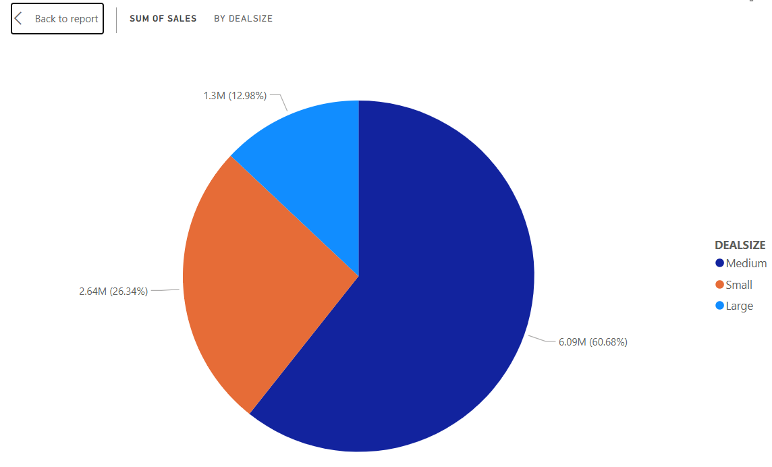
From the data we can conclude that Medium deals represent 61% of the total sales and 53% of the total orders.
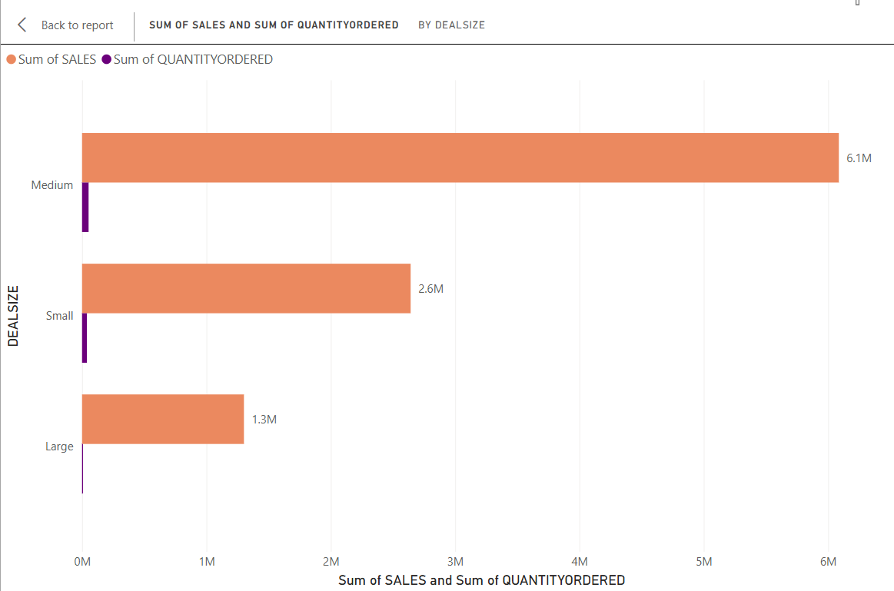
In determining which months see the largest volumes in sales I used the variables “SALES” “ORDERDATE-MONTH” and “ORDERDATE-YEAR.” For this analysis I received the years of sales for 2023,2024 and 2025; though taking into consideration that 2025 still active we do not have an entire year of data, we have enough for sufficient analysis. In 2023 we see peak sales in October and the biggest rise in November with total sales of $1,029,837.66. Comparatively 2024 shows peak sales in August, September and the biggest peak occurring in November with total sales of $1,089,048.01. From the data provided for 2025 we see that there is already a peak in sales in the month of May, also noting that the total sales are significantly higher than the two previous years. Though there is not a full year of data for 2025 we can predict a high sales month in November as well as having a larger total sales than the two previous years. This visualization also shows that every year produces an overall higher sum of sales per month than the previous years.

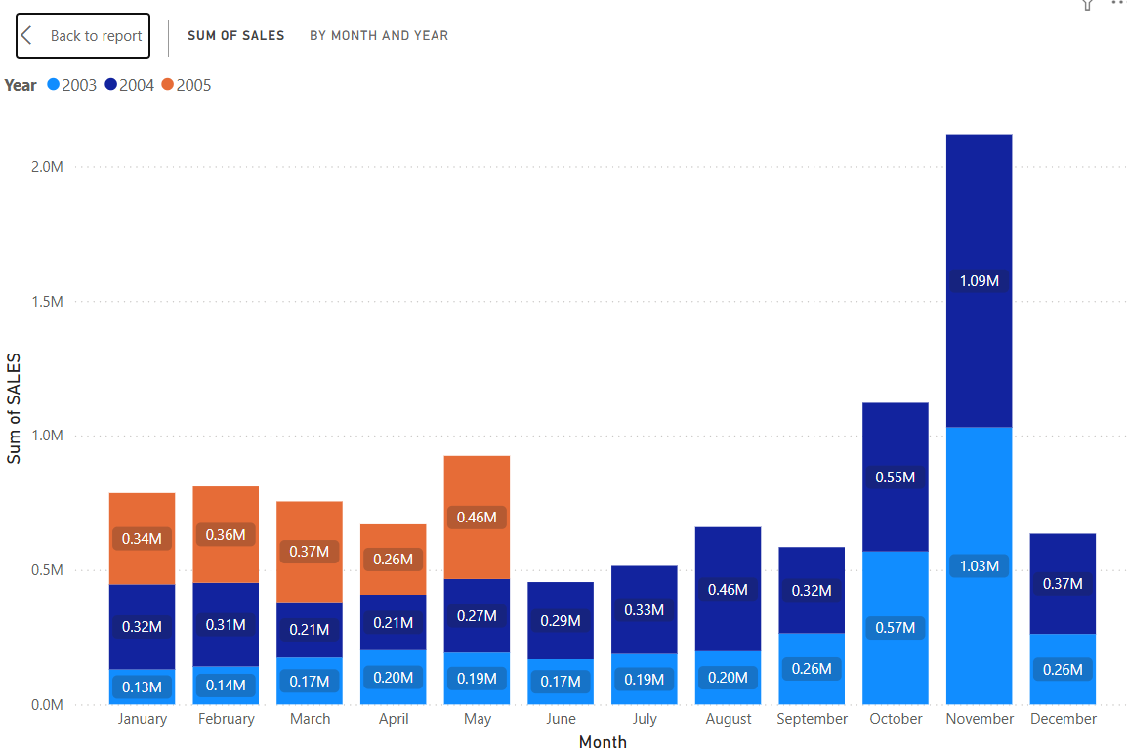
Upon reviewing the data, it is not possible to determine which territory accounts for the largest amount of sales. The available information includes sales figures, product quantities sold, and aggregated totals by year, month, quarter, and day. However, it lacks specific territorial or geographic identifiers. Customer phone numbers could potentially assist in identifying territories, but reliability is a concern, especially if customers have relocated. To address this limitation, the dataset would need additional fields defining territories, established and formatted according to organizational standards.

